CHAPTER 1
Economics: Foundations and Models

- Chapter Summary
- Learning Objectives
- Chapter Outline
Teaching Tips/Topics for Discussion
- Solved Problems
- Solutions to Review Questions and Problems and Applications

1. Chapter Summary

People must make choices as they try to attain their goals. These choices reflect trade-offs people make because we live in a world of scarcity; although our wants are unlimited, the resources available to satisfy our wants are limited. Economic models are simplified versions of some aspects of economic life. Economists construct models and use them to analyze economic issues. Economics focuses on the decisions buyers and sellers make through markets. Economists assume people (1) are rational, (2) respond to economic incentives, and (3) make optimal decisions at the margin.
Each society faces the economic problem of having a limited amount of resources, and so can produce a limited amount of goods and services. Each society faces trade-offs, particularly when answering three questions: (1) What goods and services will be produced? (2) How will the goods and services be produced? (3) Who will receive the goods and services produced? Societies organize their economies in two main ways to answer these questions. A society can have a centrally planned economy characterized by extensive government decision making. Or a society can have a market economy in which the decisions of households and firms interacting in markets allocate resources. All the high-income democracies have predominately market economies with some central government control. Market economies tend to allocate resources more efficiently than do centrally planned economies, but efficient outcomes may not be perceived as fair. Determining what is a fair or equitable outcome calls for the application of normative economic analysis – what ought to be. Positive economic analysis is concerned with what is. While most or all economists can agree on the results of positive economic analysis, they may disagree widely on normative economic issues.
Microeconomics is the study of how individual choices are made by households, business firms, and government. Macroeconomics is the study of the economy as a whole.
The Appendix to Chapter 1 provides a review of basic mathematical tools and techniques that will be applied through the textbook.
2. Learning Objectives

Students should be able to:

- Discuss these three important ideas: People are rational. People respond to incentives. Optimal decisions are made at the margin.
- Discuss how an economy answers these questions: What goods and services will be produced? How will they be produced? Who will receive the goods and services?
- Understand the role of models in economic analysis.
- Distinguish between microeconomics and macroeconomics.
- Become familiar with important economic terms.

3. Chapter Outline

What Happens When U.S. Firms Move to China?
1. In 2004, Massachusetts-based 3Com Corporation introduced a new network switch for corporate security systems that was manufactured in China and designed by Chinese engineers. This is an example of outsourcing; that is, firms choosing to produce goods and services in other countries and employing people in those countries.
►Teaching tips: This introduction, or chapter opener, describes an economic issue related to the theme of the chapter. An article from the magazine The Economist is cited at the end of the chapter in a feature titled An Inside Look. An Inside Look includes questions that require students to think critically about the issues covered in the article. These two features also appear in subsequent chapters. They can be used as the basis for classroom discussion, homework assignments, and examination questions.
Introduction
1. People must make choices as they try to attain their goals. The choices people make reflect the trade-offs made necessary by scarcity.
- Scarcity is the situation in which unlimited wants exceed the limited resources available to fulfill those wants.
- Economics is the study of the choices people make to attain their goals, given their scarce resources.
- An economic model is a simplified version of reality used to analyze real world economic situations.
►Teaching tips: It is important to define economics and explain what scarcity means at the beginning of the course, especially because many students will not have studied economics previously. Some students will better understand what scarcity means if they are given examples of things that are not scarce. Some examples of “free resources” – sand on a beach, fresh air – can be suggested. The list of free resources is very much shorter than the list of scarce resources.
Building a Foundation: Economics and Individual Decision Making
1. A market is a group of buyers and sellers of a good or service and the institution or arrangement by which they come together to trade.
2. There are three important ideas students should understand in order to understand how people make choices and interact in markets: People are rational, people respond to economic incentives, and optimal decisions are made at the margin.
3. Marginal analysis involves comparing marginal benefits and marginal costs.
►Teaching tips: One need not spend a lot of class time with explanations, since subsequent chapters will reinforce students’ understanding of what markets are and the “three ideas.” But providing examples of unconventional markets – for example, an online book vendor – will help students realize that markets may not have well-defined geographic dimensions, and interaction between buyers and sellers can be very impersonal. Students often assume that rational people who respond to economic incentives are necessarily greedy and selfish. This is not always true. Many rational people contribute to charities and receive satisfaction from working with and helping others.
The Economic Problem That Every Society Must Solve
1. Any society faces the economic problem that it has only a limited amount of economic resources and so can produce only a limited amount of goods and services.
- Society faces trade-offs. A trade-off is the idea that because of scarcity, producing more of one good or service means producing less of another good or service.
- Trade-offs force society to answer three fundamental questions:
  - What goods and services will be produced?
  - How will the goods and services be produced?
  - Who will receive the goods and services?
2. Societies organize their economies in two main ways:
- A centrally planned economy is an economy in which the government decides how economic resources will be allocated.
- A market economy is an economy in which the decisions of households and firms interacting in markets allocate economic resources.
►Teaching tips: Use one commodity – for example, corn, wheat, rice, or potatoes – and ask students for answers to the three questions and who in the United States is responsible for answering them. Most people take for granted that these questions must be answered continually for these and millions of other goods and services.
The Modern “Mixed” Economy
1. The high rates of unemployment and business bankruptcies of the Great Depression caused a dramatic increase in government intervention in the economy in the United States and other market economies.
- Some government intervention is designed to raise the incomes of the elderly, the sick, and people with limited skills.
- In recent years, government intervention has expanded to meet social goals such as protection of the environment and the promotion of civil rights.
- Some economists argue that government intervention makes it more accurate to refer to the U.S. and other nations as mixed economies rather than market economies.
- A mixed economy is an economy in which most economic decisions result from the interaction of buyers and sellers in markets, but in which the government plays a significant role in the allocation of resources.
- In recent years, China has moved from being a centrally planned economy to being a more mixed economy. Production of most goods is determined in markets.
2. Market economies tend to be more efficient than planned economies. There are two types of efficiency.
  - Productive efficiency occurs when a good or service is produced at the lowest possible cost.
  - Allocative efficiency is a state of the economy in which production reflects consumer preferences; in particular, every good or service is produced up to the point where the last unit produced provides a marginal benefit to consumers equal to the marginal cost of producing it.
  - Voluntary exchange is the situation that occurs in markets when both the buyer and seller of a product are made better off by the transaction.
3. Markets promote efficiency but don’t guarantee it. Inefficiency arises from various sources.
- It may take time for firms to achieve productive efficiency.
- Governments may reduce efficiency by interfering with voluntary exchanges in markets.
- The production of some goods may damage the environment when firms ignore the costs of environmental damage.
4. Society may not find efficient economic outcomes to be desirable. Many people prefer economic outcomes that they consider fair or equitable even if these outcomes are less efficient.
- Equity is the fair distribution of economic benefits.
- Equity is harder to define than efficiency.
- Programs designed to increase equity may reduce efficiency.
►Teaching tips: Ask students for examples of government regulation of private markets in the United States. Responses may include the prohibition of prostitution (in all but one county in Nevada); the prohibition of cocaine and other “street drugs”; minimum age requirements for the purchase of alcoholic beverages; in some regions, the prohibition of resale of tickets to concerts and sporting events; or the prohibition of the sale of new drugs before their efficacy is demonstrated through government supervised tests. One can ask students whether one of these examples promotes equity or fairness. The difficulty of defining equity will soon become apparent.
To show how students may value equity less than they claim, an economics teacher at a college in Western New York once told her students at the beginning of her course that their grades would be auctioned to the highest bidders. Since grades are typically normally distributed, she offered to sell a few A grades, a few more B grades, etc. Although this announcement produced some shock and grumbling, the auction proceeded and frenzied bidding took place for the A grades. As prices for A grades rose, bidding switched to B grades. Because few students bothered to bid for C grades, one enterprising students bid on several such grades in the belief that those who lost out on getting an A or B would have to buy their C grades from him – for a higher price than he paid! After about a week, the instructor informed the class the auction was intended only as an economics lesson; they would have to earn their grades the old-fashioned way.
Economic Models
1. Models are simplified versions of reality used to analyze real-world situations. To develop a model, economists generally follow five steps.
- Decide on the assumptions to be used in developing the model.
- Formulate a testable hypothesis.
- Use economic data to test the hypothesis.
- Revise the model if it fails to explain well the economic data.
- Retain the revised model to help answer similar economic questions in the future.
2. Models are based on our making assumptions because models must be simplified to be useful.
For example, when using models, we make behavioral assumptions about the motives of consumers and firms. Economists assume consumers will buy goods and services that will maximize their satisfaction.
Economists assume firms will act to maximize their profits.
3. An economic variable is something measurable that can have different values, such as the wages of software programmers.
- A hypothesis in an economic model is a statement that may be correct or incorrect about an economic variable.
- An economic hypothesis is usually about a causal relationship; for example, “outsourcing leads to lower wages for software programmers.”
4. Positive analysis is analysis concerned with what is. Normative analysis is analysis concerned with what ought to be.
►Teaching tips: In each chapter, between two and four Making the Connection features present relevant, stimulating, and provocative business news stories. Students have probably heard much about outsourcing over the past few years. Encourage your students to read Making the Connection 1-1. A classroom discussion on outsourcing can be based on this reading; you may ask one or more students to find a current newspaper or magazine article that supports the opposing arguments of Paul Samuelson and Jagdish Bhagwati.
Microeconomics and Macroeconomics
1. Microeconomics is the study of how households and businesses make choices, how they interact in markets, and how the government attempts to influence their choices.
2 Macroeconomics is the study of the economy as a whole, including topics such as inflation, unemployment, and economic growth.
►Teaching tips: Encourage students to read the “Don’t Let This Happen to You!” feature that highlights common pitfalls. This feature appears in the other chapters of the textbook. In this chapter, students are warned not to confuse positive and normative analysis, a pitfall to which many students fall prey.

4. Solved Problems
►Teaching tip: We always tell our students that learning economics requires hands-on problem solving with paper and pencil or pen. As we all know, many students have great difficulty in handling applied problems. The chapters of the textbook include worked-out problems titled “Solved Problems” – tied to select chapter-opening learning objectives. This feature helps students focus on the main ideas of each chapter and gives them a model of how to solve an economic problem by breaking it down step by step.
Encourage students to check their understanding of the Solved Problems in the book by completing the parallel problems that appear in the “Problems and Applications” section at the end of each chapter.

Here are three additional Solved Problems that you can present in class.

Solved Problem 1-2 Supports Learning Objective 2: Discuss how an economy answers these questions: What goods and services will be produced? How will they be produced? Who will receive the goods and services?

Giving Advice to New Government Leaders

Suppose that a developing nation experienced a change in government leadership. Prior to this change the nation employed a centrally planned economy to allocate its resources. The new leaders are willing to try a different system if they can be convinced that it will yield better results. They hire an economist from the United States to advise them and will order their citizens to follow this advisor’s recommendations for change. The economist suggests that a market economy replace central planning to answer the nation’s economic questions (what, how and who?).
- What will the economist suggest the leaders order their citizens to do?
- Do you believe the leaders and citizens will accept the economist’s suggestions?

Solving the Problem:
Step 1: Review the chapter material. The problem concerns the choice of economic system a nation must make, so you may wish to review the section titled Centrally Planned Economies versus Market Economies on page 8 of the textbook.
Step 2: What will the economist suggest the leaders order their citizens to do?
Since market economies allow members of households to employ self-interest to select occupations and purchase goods and services, and for production of goods and services to be done by privately-owned firms who respond to their own self-interest, the rulers would be told to not issue any orders. Government officials should have no influence over individual decisions made in markets.
Step 3: Do you believe the leaders and citizens will accept the economist’s suggestions?
Even democratically elected rulers, especially those with previous experience with significant government involvement in the nation’s resource allocation, will find it difficult to accept the new system. They may wonder how self-interested individuals will produce and distribute goods and services so as to promote the welfare of the entire nation. This new system requires a significant reduction in government influence in people’s lives; history has shown that government officials are often reluctant to give up this influence. Acceptance is most likely when the rulers have some knowledge and experience with the successful operation of a market economy in other countries. Ordinary citizens are more likely to accept the economist’s suggestions since they will have more freedom to pursue their own economic goals.

Solved Problem 1-3 Supports Learning Objective 3: Understand the role of models in economic analysis.

Sunspot Activity and Economic Growth

Sunspots are sites of strong magnetic fields that appear as dark regions on the surface of the sun. The number of sunspots varies over an 11-year cycle. British economist William Stanley Jevons (1835-1882) advanced a theory, or model, of economic growth based on the occurrence of sunspots. Changes in the number of sunspots cause variations in the earth’s temperature and, according to this theory, changes in agricultural output. Agriculture accounted for a much greater share of total output of the economies of Great Britain and other nations in Jevons’ time than in modern times.

How can a sunspot model of economic growth be developed and tested?

Solving the Problem:
Step 1: Review the chapter material. The problem concerns how models are used to analyze economic issues, so you may wish to review the section “Economic Models,” which begins on page 10 of the textbook.
Step 2: To develop a model, the following steps are taken:
- Decide on the assumptions to be used in developing the model. Two assumptions of Jevons’ model are: (a) changes in the earth’s temperature are related to the amount of sunspot activity. (b) changes in the earth’s temperature cause variations in the value of a nation’s output of goods and services.
- Formulate a testable hypothesis. The value of a nation’s output of goods and services is greater in years of greater than average sunspot activity than in years of lower than average sunspot activity.
- Use economic data to test the hypothesis. Compare changes in sunspot activity with changes in a standard measure of the value of a nation’s output of goods and services; the most common measure is Gross Domestic Product or GDP. Since sunspot activity varies in 11 year cycles, data should cover at least one of these cycles. If data for the United States are used, years of greater than average sunspot activity should be associated with years of above average economic growth, while years of lower than average sunspot activity should be associated with years of below average economic growth.
- Revise the model if it fails to explain properly the economic data. The model could fail if factors other than sunspot activity have a significant impact on economic growth. These factors could include variations in the price of energy; investments in new technologies; changes in tax rates and other government policies. A revised model could examine the separate influence of sunspots and these other factors.
- Retain the revised model to help answer similar economic questions in the future. Although the sunspot model is based on a plausible relationship between climate changes and changes in agricultural production, agriculture accounts for a much smaller percentage of the output produced in the United States, Great Britain and other western nations in the twenty-first century than it did in the nineteenth century. In turn, other factors have shown to be important in affecting economic growth.

Solved Problem 1-4 Supports Learning Objective 4: Distinguish between microeconomics and macroeconomics.

Watching From On High - or Low

Sports fans are used to seeing game action on television from different camera angles. For popular events such as the Olympics, World Series and Super Bowl, network coverage captures action from ground level as well as from higher angles. At many events there is a camera located in a blimp that circles above the venue where the event is held. The aerial view of the blimp’s camera is often visually appealing but is never broadcast for very long; the athletes can only be seen from a great distance, if they can be seen at all. Coverage of the events also includes a view from a mobile or “sideline” camera that can zoom in on individual players or fans sitting in the stands, a degree of detail in stark contrast to that provided by the aerial view.

Solving the Problem:
Step 1: Review the chapter material. The problem concerns the differences between microeconomics and macroeconomics, so you may wish to review the section “Microeconomics and Macroeconomics,” which begins on page 13 of the textbook.
Step 2: Compare the focus of microeconomics with the television coverage of a sports event. Microeconomics focuses on how individual households and firms make decisions and how government attempts to influence these choices. This focus is similar to that of a sideline camera at a football game. The camera can focus in on an individual player or fan.
Step 3: Compare the focus of macroeconomics with the television coverage of a sports event. Macroeconomics studies the economy as a whole, including topics such as economic growth. Macroeconomics does not study the decisions made by individuals but the consequences of the actions of all decision-makers in an economy. This is similar to the focus of a blimp’s aerial view of the venue where a sports event occurs. One can see the entire venue, but the blimp’s point of view is too far away to see any individual player or fan.
CHAPTER 1 Appendix
Using Graphs and Formulas

Graphs of One Variable
1. Bar graphs, pie charts and time-series graphs are alternative means for presenting data.
- The height of a bar in a bar graph represents the value of a variable.
- A pie chart can be used to illustrate information such as the market shares of groups of firms. Each share is represented by the size of its slice of the pie.
- Time-series graphs are displayed on a coordinate grid.
  - The vertical axis (y-axis) of a coordinate grid measures the value of one variable. The point where the vertical axis intersects the horizontal axis is the origin.
  - The horizontal axis of a coordinate grid measures the value of another variable.
  - The points in a coordinate grid represent the values of the two variables.
2. Relationships are usually easier to discern with graphs than with words or tables alone.
►Teaching tips: Examples of bar graphs, pie charts and time-series graphs are shown in Figures 1A-1 and 1A-2. Students should be able to read and understand these graphs on their own. Most of the graphs they will encounter in microeconomics will be graphs of two variables.
Graphs of Two Variables
1. Both microeconomics and macroeconomics use two-variable graphs extensively.
- Figure 1A-3 illustrates the graph of a linear or straight-line demand curve.
- Price is measured along the vertical axis and quantity is measured along the horizontal axis.
- The slope of a straight line indicates how much the variable measured along the y-axis changes as the variable measured along the x-axis changes.
- Slope can be measured between any two points on the line since the slope of a straight line has a constant value.
- Slope can be measured in the following ways:
- The change in the value measured on the vertical axis divided by the change in the value measured on the horizontal axis.
- Δy/Δx, where the Greek letter delta (Δ) stands for the change in a variable.
- “Rise over run” between two points on a straight line, where rise refers to the change in the variable whose values are measured on the graph’s vertical axis, and run refers to the change in the variable whose values are measured on the graph’s horizontal axis.
- The greater the value of the slope (ignoring the sign), the steeper the line will be. The smaller the value of slope (ignoring the sign), the flatter the line will be.
2. Demand curves show the relationship between two variables, but the quantity of a good sold depend on variables other than price.
- Allowing other variables that affect demand to change changes the position of the demand curve.
- Figure 1A-5 shows how a change in a variable other than price will shift a demand curve.
- An increase in demand is a shift in the demand curve to the right.
- A decrease in the demand curve is a shift in the demand curve to the left.
3. The relationship between quantity demanded and price is negative.
- The slopes of other relationships can be positive.
- A positive relationship between two variables, disposable personal income and consumption spending, is shown in Figure 1A-6.
4. Some variables have nonlinear relationships.
- Figure 1A-7 illustrates a nonlinear relationship between the total cost of production and the quantity produced of iPods.
- The slope of a nonlinear relationship, or a curve, is not constant.
- To measure the slope of a nonlinear curve at a particular point, one must measure the slope of a tangent to the curve at that point.
- A tangent line touches the curve at only one point.
- The slope of a tangent is measured in the same way as the slope of any straight line.
►Teaching tips: The appendix may be assigned as on “on your own” reading. But don’t assume students will understand the formula for computing a slope. A review of the slope formulas will be time well spent, either at this point in the course or when these formulas are first applied. Unlike bar charts and pie charts, graphs of two variables will be used extensively throughout the remainder of the text.
Formulas
1. The formula for a percentage change in a variable between two periods is is: (Value of variable in period 2 – Value of variable in period 1)/Value of variable in period 1.
- The formula for the area of a rectangle is base x height.
- The formula for the area of a triangle is ½ x base x height.
- Figure 1A-8 illustrates the area of a rectangle.
- Figure 1A-9 illustrates the area of a triangle.
►Teaching tips: As with the slope formula, do not assume your students will know how to a compute a percentage change or the areas of a triangle or rectangle. Consider assigning Problems and Applications numbers 3 through 6 as homework assignments to reinforce students’ understanding of these important formulas.

We always tell our students that learning economics requires hands-on problem solving with paper and pencil or pen. As we all know, many students have great difficulty in handling applied problems. The chapters of the textbook include worked-out problems titled Solved Problems – tied to select chapter-opening learning objectives. This feature helps students focus on the main ideas of each chapter and gives them a model of how to solve an economic problem by breaking it down step by step. Encourage students to check their understanding of the Solved Problems in the book by completing the parallel problems that appear in the Problems and Applications section at the end of each chapter.
5. Solutions to Review Questions and Problems and Applications

Answers to Thinking Critically Questions

1. The article suggests that outsourcing to China will benefit most people in the countries that trade with China, but that it will harm some workers in these countries, too – requiring them to look for new jobs. Equity or fairness is hard to define. Some will see a change in which most win but some lose as unfair, but others won’t.

2. The article suggests that the economy is very complicated and always changing, so that isolating the impact of outsourcing will be very difficult. For example, one group estimates that outsourcing (or “offshoring”) will cost the United States three million manufacturing jobs over three years, but it is difficult to isolate the impact of this development, so the paragraph continues that “most of these job losses were likelier to have been caused by the recession or by labour-saving IT investment.”

Answers to Review Questions

1. Scarcity is the situation in which unlimited wants exceed the limited resources available to fulfill those wants. Economics is the study of the choices consumers, business managers and government officials make to attain their goals. Scarcity is central to economics because scarcity requires people to make choices about how to use their resources to best fulfill their wants.

2. “People are rational” is the assumption that decision makers explicitly or implicitly weigh the benefits and costs of each action, and then choose an action only if the benefits are expected to outweigh the costs. “People respond to incentives” means that people respond to economic incentives – they may change their behavior if the expected benefits or costs of an action change by enough. “Optimal decisions are made at the margin” means that most decisions are not “all or nothing,” but involve doing a little more or a little less of an activity. Thus, the optimal decision is to continue any activity up to the point where the marginal benefit equals the marginal cost.

3. The three economic questions that every society must answer are: 1) What goods and services will be produced? 2) How will the goods and services be produced? 3) Who will receive the goods and services? In a centrally planned economy, most of these decisions are made by the government. In a market economy, almost all of these decisions are made by the decentralized interaction of households and firms in markets. In a mixed economy, most economic decisions result from the interaction of buyers and sellers in markets, but government plays a significant role in the allocation of resources.

4. Productive efficiency occurs when a good or service is produced at the lowest possible cost. Allocative efficiency means that what is produced reflects consumer preferences – every good or service is produced up to the point at which the last unit provides a marginal benefit to consumers equal to the marginal cost of producing it.

5. Efficiency is concerned with producing the goods and services that people want at the lowest cost. Equity is “fairness,” a concept that can differ dramatically from person to person. Government policymakers often want to make economic outcomes “fairer,” but this often involves redistributing income from one group to another, which usually (but not always) hampers efficiency because it reduces incentives to produce and drives up production costs.

6. Economists use models for the same reason that any other scientist (and indeed everyone else) does – to make the complicated world simple enough so that it can be understood and analyzed, so that questions about it can be usefully answered. Useful models will generate testable predictions. If these predictions accord with economic data, then the model isn’t rejected and can be used to understand the economy. Testing models with data can be very difficult, however, because the economy is always changing – it is virtually impossible to conduct controlled economic experiments.

7. In arriving at a useful economic model, these five steps are followed: 1) decide on the assumptions to be used; 2) formulate a testable hypothesis; 3) use economic data to test the hypothesis; 4) revise the model if it fails to explain well the economic data; and 5) retain the revised model to help answer similar economic questions.

8. Positive economic analysis concerns what is, i.e., it deals with how the economy actually behaves. Normative economic analysis concerns what ought to be. Economics is mainly concerned with positive analysis – conceptualizing and measuring the costs and benefits of different courses of action. However, decision makers (including voters and government officials) will want to use the tradeoffs identified by positive economic analysis in normatively deciding what course of action should be taken.

9. Microeconomics is the study of how households and firms make choices, how they interact in specific markets, and how the government influences their choices. “Micro” means small, and microeconomics deals with individual decision makers. Macroeconomics is the study of the economy as a whole. “Macro” means large, and macroeconomics deals with economy-wide outcomes, such as the inflation rate, the unemployment rate, and the economic growth rate.

Answers to End-of-Chapter Problems and Applications

1. To quote further from McTeer: “You’ve learned a systematic, disciplined way of thinking that will serve you well.” Economics teaches us how to look at the tradeoffs involved in every decision. Those who cannot conceptualize the costs of an action and weigh them against its benefits are unlikely to make good decisions. As one climbs the corporate or governmental ladder, one is required to make a wider and wider array of such decisions.

2. Yes, even Bill Gates faces scarcity because his wants exceed his resources. Gates has established a foundation with billions of dollars to spend on worthy causes like eradicating malaria and reducing homelessness. However, there are an unlimited number of worthy causes that Gates desires to fund, so even he faces scarcity. Secondly, even Gates has only twenty-four hours in a day, so he must make choices about how to spend his scarce time. Everyone I know faces scarcity, because human desires are virtually unlimited. Because the world’s resources are limited, the only way to not face scarcity is to reduce one’s wants to be less than one’s resources.

3. Economists assume that people are rational in the sense that their actions are intended to achieve their goals. This does not mean that economists assume everyone is a genius or always makes the “right” decision in every circumstance. It does mean that economists assume that the actions of consumers and businesses reflect their attempts to achieve their goals.

4. The manager is failing to think at the margin. Dell has lost $400,000 on the last 10,000 laptops, so their profits would have been higher if they had not produced them.

5. Jill is correct because profit equals revenue minus cost.

6. Your friend is failing to think at the margin. It doesn’t matter how much time has already been spent studying psychology. What matters is the marginal benefit to be received from studying psychology relative to the marginal cost, where cost is measured as the opportunity cost of lower grades in other subjects. If the course is required, that may raise the marginal benefit.

7. As noted in the chapter, the economic incentive to banks is clear – it is less costly to put up with bank robberies than to take these additional security measures.

8. The contractors had little incentive to deliver the Indians to Oklahoma alive. Instead, they benefited when the Indians died along the way, because they had to spend even less money on food and transportation. One way to change the incentives to lower the death rate would have been to pay the contractors more if the Indians arrived safely in Oklahoma.

9. The model should be revised in light of its failure to explain or predict real world events.

10. The problem with Dr. Strangelove’s theory is that it cannot be tested unless we can devise a way to measure the emission of these subatomic particles, which seems to be impossible since they don’t exist in our universe. Because we cannot test the model’s predictions, it is not very useful to us – even though it might be true, we have no way of knowing.

11. Managers in a market system generally have a greater economic incentive to adopt better machinery and equipment whenever the benefits to their company exceed the costs. Managers in centrally planned economies rarely are rewarded as directly for such decisions and they rarely are given the authority to carefully weigh costs versus benefits in making decisions.

12. a. It is doubtful that centrally planned economies have been less efficient purely by chance. The underlying reason seems to be that centrally planned economies don’t give as great incentives for hard work and innovation as market economies do. In addition, the people running centrally planned economies cannot make the most productive decisions because they don’t have the information that is in the minds of all the decentralized decision makers in a market economy.
b. You might still prefer having a centrally planned economy if you considered it to be more equitable. (Also, you might prefer a centrally planned economy if you were in charge.)

13. If an economic system didn’t put in place some restrictions, such as laws against theft, it could reduce both the efficiency and equity of the system. A major restriction of the market economy is that you can only get a good or service if you have enough money to purchase it.

14. a. The groups that are most likely to get the tickets will be those for whom the expected marginal benefit of going to City Hall on Monday morning is greater than the expected marginal costs. These might include people who have a very low opportunity cost of traveling to City Hall and standing in line, such as people who don’t have a job in the morning and those who live or work very close by. These might also include people who see a large benefit from going to get the tickets, such as die-hard NASCAR fans or professional ticket scalpers.
b. The major opportunity cost of distributing the tickets this way is the cost to the people who attempt to get the tickets – the cost of travel to City Hall, the activities that cannot be done (such as earning money at work) when one is standing in line, and the costs to all those people who try to get tickets but don’t get there soon enough. (There’s also the cost of people blocking traffic in and around City Hall.)
c. This isn’t an efficient way to distribute the tickets, since it wastes so much time. Perhaps the most efficient way to distribute the tickets is to hand them out unannounced to people walking by – this would take only a few minutes. Alternatively, the city could sell them back to NASCAR and have them distribute the tickets.
d. Equity is hard to define. Some people will see this as equitable, since only the deserving, true fan will put up with the hassle of getting the tickets. Others will disagree, saying that no money was raised for the taxpayers of the city, who deserve to get the benefits of selling the tickets since they fund the police department.

15. a. The central reason for outsourcing to China is that firms believe they can earn a higher profit in the process.
b. Outsourcing to China isn’t risk-free. In most cases, the entrepreneur has no guarantee that the costs of outsourcing (payments to the workers plus costs of arranging things and supervising from a distance, for example) will be lower than the costs of production with domestic workers whose productivity and quality of workmanship may be much higher.

16. a. and c. are positive statements; b. and d. are normative statements.

17. a. and d. are microeconomic questions; b. and c. are macroeconomic questions.

18. a. The proposal might protect consumers because lawyers are generally better trained and more knowledgeable about these matters than non-lawyers.
b. The law will clearly protect lawyers by reducing the competition facing them and allowing them to increase their prices. The gains to consumers may be very small since consumers are often wise enough to know when going to a lawyer is their best decision and when relying on someone with less training is acceptable.
c. Answers will vary, but people will tend to favor the law if they have financial ties to lawyers, or they suspect that the advice from these non-lawyers will be incompetent. Also, people will tend to oppose the law if they think that consumers are in a good position to decide for themselves who is offering good advice at a good price.

Answers to Problems and Applications in the Appendix

1a. negative
b.

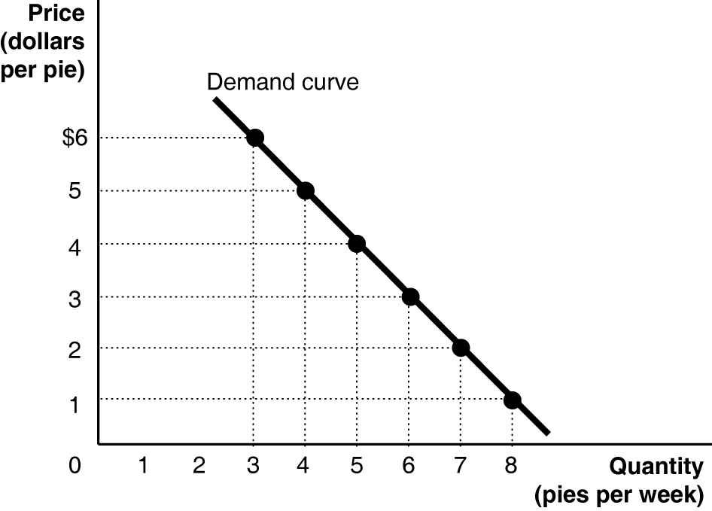

c. The slope = –1.

2.

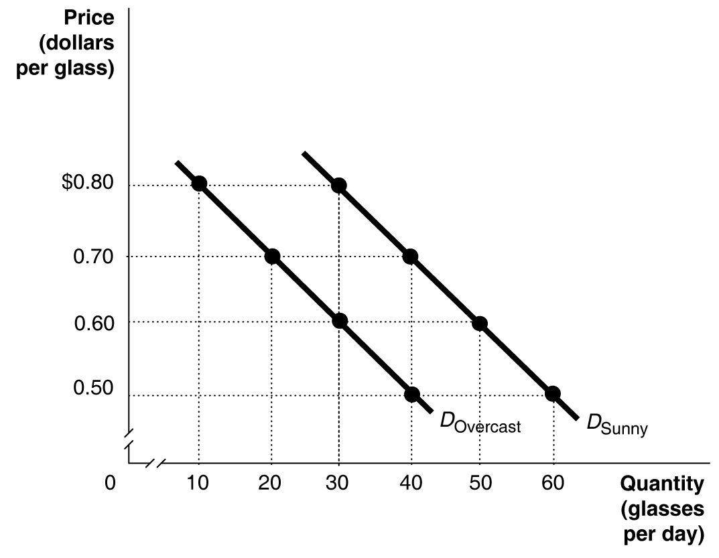

3. Period Percentage Change
1999 to 2000 +2.8%
2000 to 2001 –5.4%
2001 to 2002 0%
2002 to 2003 –4.3%
Sales fell the fastest between 2000 and 2001.

4. –1.9%. The percentage change in real GDP from one year to the next is the economy’s growth rate.

5. a.

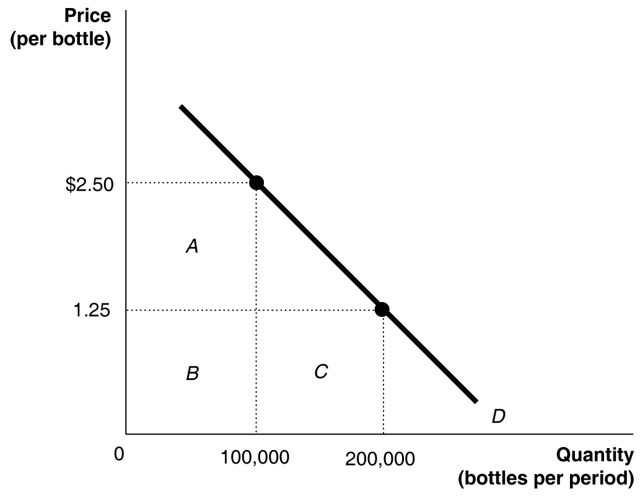

b. At $2.50, the total revenue equals rectangles A + B = $250,000. At $1.25, the total revenue equals rectangles B + C = $250,000.

6. The triangle’s area = 0.5 x 60,000 x $0.75 = $22,500.

